Effects of Great Recession on Income Poverty in households with working-age adult with disability

Subharati Ghosh, Subhrangshu Nandi, Susan Parish

**Abstract:**

**INTRODUCTION**

According to the National Bureau of Economic Research (NBER), the Great Recession officially lasted from December 2007 to June 2009. The Great Recession is considered one of the worst economic down times since the Great Depression of the 1930’s (Danziger and Danziger 2013), with historically the slowest recovery (Hoynes, Miller, and Schaller 2012). Three simultaneous adverse events – housing crisis, employment crisis, and financial crisis (Danziger, Chavez, and Cumberworth 2012) marked the period and impacted various aspects of the economic well-being of Americans. However, the intensity of the impact was not homogeneous across different social groups.

One such historically disadvantaged group is working-age adults with disabilities (ages 18 to 64), who in general experience higher rates of material hardships and poverty compared to their non-disabled peers (Brucker, Mitra, Chaitoo, and Mauro 2015). We do not know, how the Great Recession of 2007-09 impacted working-age adults with disabilities. Of the few studies that did focus on working-age adults with disabilities, topics of inquiry were largely limited to employment outcomes (Kaye 2010; Fogg et al. 2010, Schneider 2011) or poverty, either aggregated annually (Livermore and Honeycutt 2012) or estimated at one point-in-time (Drew 2015). Such aggregations or point-in-time measures fail to capture the complexity, given that the recession lasted for a year and a half, yet had the slowest recovery rate (Hoynes, Miller, and Schaller 2012). In other words, we not only lack information on how working-age adults with disabilities fared during the Great recession compared to their non-disabled counterparts, but also on how the recession inordinately impacted specific sub-groups of working-age adults with disabilities.

We address the gaps in knowledge by leveraging longitudinal data from the Survey of Income and Program Participation (SIPP) and fits in a mixed-effects regression model to assess levels and trends in the income-poverty ratio over time during the Great Recession and four years following its official exit. An advantage of using a mixed-effects method is that it will control for the differences between households, and reduce bias by generating more robust estimates of the income-poverty ratio over time. The information generated could then be used by policy makers to assess the duration of impact of the latest recession on the economic well-being of households with working-age adults with disabilities, and the time it took for these households to return to pre-recessionary levels, if at all, compared to households without working-age adults with disabilities. We also estimate income-poverty ratio profiles of different subgroups of households during the same period. By testing interaction effects between the different demographic sub-groups (such as race, ethnicity, gender and marital status of the household head) and disability status of a working-age adult with a disability in the household, will help identify households that were most vulnerable to the economic shocks of the great recession.

The current study also estimates rates of material hardships experienced in households with working-age adults with disabilities, compared to their counterparts. It is now widely known that the current US income poverty measure fails to account for the true extent of financial strain in US households (Oulette et al., 2004). Alternative measures, such as material hardships are frequently used to capture the true extent of financial strain in US households. In the 2008 panel, the SIPP for the first time collected hardships data twice. We use the rich data and compare households with a working-age adult with disabilities to those not at two points in time, and assess whether hardships changed over time. The two time points coincide one and two years following the official ending of the Great Recession. Using both income-poverty ratio and hardship measures allow us to create a complete profile of economic well-being of households with working-age adults with disabilities and assess how they compare to households without working-age adults with disabilities during the Great Recession.

**Prior Literature**

*The impact of the Great Recession on individual and family economic well-being*

The US Great Recession of 2007-09 was marked by loss of employment, income, wealth, and assets (Pfeffer, Danziger, and Schoeni 2013), and an increase in unemployment and poverty rates (Hoynes, Miller, and Schaller 2012). From 2008 to 2013 (four years after the official end date), the US economy saw a job decline of 6% and a drop in family income by 8% (Danziger and Danziger 2013). Four years post- recession, the official monthly unemployment rate remained high at 7.5% (June 2013), higher than the pre-recession rate of 4.7% in November 2007 (Bureau of Labor Statistics). The rate of poverty increased from 12.5% in 2007 to 14.3% in 2009, and high at 15% during 2011 and 2012, similar to poverty rates during the recessions of 1980’s and 1990’s (United States Census Bureau). US households also experienced loss of wealth (Pfeffer, Danziger, and Schoeni 2013) and assets, and an increase in debts (Hurd and Rohwedder 2010) during the period. At least a fourth of all American households lost 75% of their wealth, and a quarter lost 25% of their wealth between 2007 and 2011 (Pfeffer et al. 2013). In all, the Great Recession impacted various aspects of Americans economic well-being.

Although the Great Recession had an impact on the whole economy, its effect on individuals and households were not uniform (Hoynes, Miller, and Schaller 2012; Pfeffer, Danziger, and Schoeni 2012). For example, during the Great Recession, *unemployment* rates were higher among single women, those with a high school degree, African Americans and Hispanics, and those between ages 25 and 44, compared to, married, White, more educated and older male Americans over age 44 (Hoynes, Miller, and Schaller 2012). Similarly, *wealth* loss during the Recession was concentrated disproportionately among households headed by young and middle-aged Hispanics and African Americans, those with less education and income and those whose net worth was below 75th percentile of the wealth distribution (Taylor et. 2010; Wolff, Owens, and Burak 2011; Bricker et al. 2012; Emmons and Noeth 2012; Pfeffer, Danziger, and Schoeni 2013; Shapiro, Meschede, and Osoro 2013). Similarly, *poverty* rate although increased through the Great Recession (12.5% to 15%, 2007-2011), it was significantly higher among young adults between ages 18 to 24, who experienced an increase of 4.7 percentage points compared to adults between ages 25 and 64, who experienced increase of three percentage points in poverty during the same period (Danziger, Chavez, and Cumberworth 2012). For adults between ages 24 and 64 with less than high school education, poverty grew by 5.5% compared to those with a college degree (1.1%). Racial differences in poverty rates were also evident. White non-Hispanics experienced a 2.2 % increase in poverty from 2007 to 2011, whereas African Americans and Hispanics experienced an increase in poverty by 3.7% and 4.5% points respectively (Danziger, Chavez, and Cumberworth 2012). Finally, households headed by single unmarried women experienced a greater increase in poverty compared to all the other groups. As expected, these historically disadvantaged groups (Danziger, Chavez, and Cumberworth 2012) also had the slowest post-recession economic recovery rate (Kochhar 2011).

Although income poverty, unemployment rates, wealth, and assets continue to be the most important markers of economic well-being, there is an increasing body of research which supports the use of alternate measures, to capture the true state of economic well-being. As such, there is an increasing push to conceptualize poverty as a deprivation of well-being or capability deprivation rather than purely a lack of income (OECD, 2011; Sen 1997, 1999; Stiglitz, Sen, and Fitoussi, 2009). In the USA the official measure of poverty, developed in the 1960’s and remains unchanged (Glennerster, 2002), is based on three times the annual household food budget accounting for household size. Individuals with total pre-tax income below the official threshold are counted as poor. The measure is important, as the official threshold continues to be a major determinant of eligibility to various safety-net programs for poor families. However, based purely on food-budget, the measure fails to account for expenses such as healthcare costs, which are integral to households with individuals with disabilities. As such supplemental measures have evolved to capture the true extent of financial strain in US households (Oulette et al., 2004). One such is material hardships, measured regarding family’s inability to meet expenses on health, gas and electricity, food, and regular expenses. Compared to income-poverty, measures of material hardships capture long-term economic hardships (Iceland and Bauman 2004). Hence, the two measures – income poverty and material hardships – are often used in conjunction to capture the true extent of economic-well-being in US households.

There is some evidence that during the Great Recession, one in five working-age individuals in the USA experienced at-least one hardship (Lerman and Zhang (2014). US households reported a reduced spending on prescription drugs and doctor visits (Hurd and Rohwedder 2010). A survey of medical care use during economic crisis in five high-income countries, such as Britain, Canada, France, Germany and USA (Lusardi, Schneider, and Tufano 2011), found almost 26.5% of Americans to reduce routine medical care, as opposed to 12% French, 10.3% German, 7.6% British and 5.6% Canadians (Lusardi, Schneider, and Tufano 2015). Americans who were unemployed and looking for work reduced their health spending by 40%, significantly higher compared to other high-income countries who experienced a decline between 14% and 28%. Other hardships experienced by US households during the recessionary period were, food insecurity, which increased from 13million in 2007 to 17.1 million in 2008 (Andrews & Nord 2009), inability to pay for regular expenses, including payments on rents and mortgages, and food insufficiency. Less frequently reported hardships were telephone or utility cut-off or facing eviction (Lerman & Zhang 2014).

Much like income poverty, material hardships were inequitably distributed among the various social groups during the recessionary period and reflective of continuing patterns of disparity existing during non-recessionary periods. For example, during the Great Recession, prescription drug use count was the lowest among Hispanics, followed by African Americans and Whites. African Americans also experienced a drop in inpatient stays during the recession, compared to pre-recession times (Burgard, Ailshire, and Kalousova 2013). On measures of food security, Hispanics and Non-Hispanic Blacks were more likely to experience food insufficiency (12.4% and 11% respectively), compared to Whites (5.2%) (Lerman and Zhang 2014). Lerman and Zhang (2014) also found 36% of Non-Hispanic Blacks to report “any hardship,” compared to 19% Whites.

In conclusion, although the economic effect of the Great Recession was all pervasive, it particularly impacted groups who for decades have been socially and economically disadvantaged irrespective of economic cycles (Danziger, Chavezand, and Cumberworth 2012), with the recession further exacerbating existing disparities and inequalities (Danziger and Danziger 2013).

***Economic well-being of individuals and households with working-age adults with disabilities***

Studies, not particular to the recession period show households with working-age adults with disabilities to report higher rates of poverty (Brucker, Mitra, Chaito, and Mauro 2015; London, Heflin and Wilmoth 2011; She and Livermore 2008), compared to households without working-aged adults with disabilities. The poor economic well-being results from direct and indirect costs that families and individuals have to bear over the lifespan (Mitra, Findley, and Sambamoorthi 2009; Newacheck and Kim 2005; Parish, Shattuck, and Rose 2009). For parents of children with disabilities, real and perceived financial inadequacy continues through life (Ghosh, Greenberg, and Seltzer 2012; Parish, Rose, and Swaine 2010; Parish, Seltzer, Greenberg, and Floyd 2004), as individuals with disabilities, such as those with developmental disabilities or mental illness are living longer and dependent on their parents.

Households with persons with disabilities also experience material hardships at higher rates compared to households that do not have persons with disabilities (Brault, 2012; Brucker, 2016; Burkhauser, Rovba, and Weathers, 2009; Cooper, O'Hara, and Zovistoski, 2011; Meyer and Mok, 2006; She and Livermore, 2007).Hardships include higher rates of food insecurity (Rose, Parish, and Yoo, 2009; Huang, Go, and Kim 2010), inability to meet basic (She and Livermore 2007; Rose, Parish, and Yoo, 2009) and medical needs, compared to households without working-age adults with disabilities. In other words, whether at the individual or at the household level, disability is a significant determinant of economic well-being.

***The Great Recession and its impact on households with working age adults with disabilities***

In spite of being a vulnerable group, there has not been any systematic investigation of household poverty among working-age adults with disabilities during the Great Recession of 2007-09. Some studies did focus on labor force participation, such as employment, and unemployment rates, exit and entry into the labor force (Kaye 2010; Fogg et al. 2010, Schneider 2011) of working-age adults with disabilities and comparing them to non-disabled US working-age adults. While others focus on the experience of recession-related events in households caring for children with developmental disability (DD) and mental illness (MI), and comparing them to a normative group of parents without adult children with disabilities (Song, Mailick, and Greenberg 2017).

Results, in general, show working-age adults with disabilities to perform worse on outcomes such as employment, unemployment, and re-entry into the workforce, compared to their non-disabled counterparts (Kaye 2010; Fogg et al. 2010, Schneider 2011). However, employment is only one aspect of economic well-being for working-age adults with disabilities, given that a significant proportion of working-age adults with disabilities at any point in time are either unemployed or underemployed, compared their nondisabled peers (Bureau of Labor Statistics 2017). Therefore, it is important to know other facets of economic well-being, such as poverty and material hardships, as experienced in households with working-age adults with a disability, and how do they compare to households without working-age adults with disabilities during the recession.

Although one study did note of poverty (Livermore and Honeycutt 2012), the analysis was limited to estimating poverty rates by aggregating annual household poverty. Using data from the Current Population Survey’s (CPS) Annual Social and Economic Supplement, Livermore and Honeycutt (2015) found higher rates of annual poverty in households with working-age adults with disabilities compared to the household without working-age adults with disabilities. The study also found both households with and without working-age adults with disabilities experience a three-percentage point increase in annual poverty between the two time-points (2006-2010).Unlike Livermore and Honeycutt (2012), Drew (2015) uses a point-in-time measure of poverty, i.e., considers a household in poverty whose income is below 100% of the federal poverty level (FPL) during the first month of the focal year. The study (Drew 2015) also estimates chronic and episodic poverty trends through the years. Although these studies provide evidence that disability is an important determinant of economic well-being during the Great Recession, any systematic investigation of poverty and material hardships, as it evolved during the Great Recession and its long wake in households that have working-age adults with disabilities has been scant.

Using only income poverty as a measure of economic hardships understates the true extent of disability related direct and indirect costs that households with individuals with disabilities have to bear (Palmer 2011). Only one study till date notes on material hardships experienced in households with working-age adults with disabilities during the Great Recession (Drew 2015). In the study 6.6% of US households with a working-age adult with disability reported food hardships, 26.8% reported medical hardships and 25.9% reported difficulty in paying bills in 2010 (Drew 2015). Group differences were also evident. Among households with working-age adults with disabilities, those with low-education (less than high school), being female and of Hispanic origin, experienced higher rates of hardships of any kind, compared to those with education greater than high school, males and of non-Hispanic origin (Drew 2015). However, Drew (2015) assessed material hardships over time in households with working-age adults with disabilities but did not assess how material hardships compare over time in households without working-age adults with disabilities, i.e., if there are trend differences over time. Given that measures of material hardships were asked twice during the course of the 2008 panel of SIPP, (2010 and 2011), gives us a unique opportunity to assess whether material hardships changed over time for households with working-age adults with disabilities to those not, one and two years’ post-recession, given that this period also intersected with the expansion of US safety-net programs, key to mitigating hardships, such as food insecurity.

There is some evidence that not all sub-groups of working-age adults with disabilities were equally impacted by the Great Recession. For example, compared to Whites (14%), African American working-age adults with disabilities between ages 25 and 34 had significantly higher rates of unemployment (34%) in 2008, which remained steady till the first quarter of 2011 (Schneider 2011). Similarly, parents of children with mental illness, younger parents and those with poor pre-recessional financial history experienced more recession-related events (anytime during the period 2007-09) compared to comparison group parents (Song, Mailick, and Greenberg 2017). Overall, the impact of the recession was not uniform across various social groups of individuals with disabilities.

In all, our current understanding of the impact of the recession on households with working-age adults is fragmented, and limited in the following ways. First, although each of the studies cited earlier uses longitudinal data, the studies did not necessarily follow the same households over-time during the Great Recession. Those that did follow the same households are limited by the frequency of the observations. For example, studies by Livermore and Honeycutt (2015), Kaye (2010) and Fogg, Harrington and McMahon (2010) uses data from the CPS, which follows households for only four consecutive months in a year, and re-interviews them once again for four consecutive months before households exit the sample completely. For analytic purposes, Livermore and Honeycutt (2015) uses only two points in time (2006 & 2010) and Fogg, Harrington, and McMahon (2010) uses data from 2008-2009, i.e., covers sixteen of the twenty-two months of the recession. Given the nature of the data used, none of these studies followed the same households over time to assess the continual impact of the recession on household economics. Although Song et al. (2017) uses the MIDUS data which follows the same households over time, the data gets collected at long intervals of time. Hence, all of these studies provide a snapshot of the effects of the Great Recession by controlling for prior levels of economic well-being but do not capture the dynamic nature of household economic well-being over time during the Great Recession. The dynamic pattern can be analyzed more precisely by analyzing data from the same households at multiple time points through the entire recession period. In addition to restrictive time points, measures of poverty used in the studies are equally limited, as noted earlier (Drew, 2015; Livermore and Honeycutt, 2015). *Second*, most of the research focuses on work-related disability or specific disabilities such as DD or MHP’s. These definitions or criteria fail to capture the entire gamut of people with disabilities who are unemployed, never employed or underemployed, to assess the impact of the Great Recession on individual or household level economic well-being. *Third*, none of the studies provide adequate evidence of how disability intersects with household socio-demographic characteristics to impact US household poverty levels during the Great Recession and its long wake. While some assess socio-demographic factors associated with recession-related events (Song et al. 2017), others provided gross estimates of change in poverty among the various sub-groups (Livermore and Honeycutt 2015) or the association of the various socioeconomic demographic factors to household economic well-being. Drew (2015) estimates material hardships within households of working-age adults with disabilities, but provides gross estimates, without testing for interaction. In all, our understanding of the impact of the Great Recession on households with working-age adults with disabilities is fragmented, and there is much scope to examine the effect in details.

The current study addresses the above limitations in the following ways. *First*, the study uses data from the Survey of Income and Program Participation, a panel data which tracks the same households over a four-year period and collects data every fourth month, enquiring key economic indicators from the previous four months. The 2008 panel (2008 to 2013) coincides with the Great Recession, which allows for tracking of monthly income and income poverty levels during the period. Using a frequent interval data helps in understanding the dynamic income poverty ratio trends in households during the recession and four years post its official end. By following the same household over a four year period also provides a more nuanced and comprehensive understanding of the impact of the recession on household economic well-being, when households have working-age adults with a disability. *Second*, SIPP has a separate module to assess adult disability, which encompasses a broad range of conditions. Using a wide definition of disability allows for including a broad range of individuals with disabilities and not restrict to only work-related disability or specific health conditions which are disabling. *Third*, the study uses ‘time’ as a continuous variable in a mixed effects regression model, compared to previous studies with either discrete time points (Livermore and Honeycutt 2015) or count of events over the whole period (Song et al. 2017). This study also uses interactions effects of socio-demographic factors. Using time as a continuous variable and adding interaction terms enables the analysis of poverty levels at any time point during the study period, along with declines and recovery patterns of poverty levels of different subgroups of household with working-age adults with disabilities.

Based on the review of the literature, the study has the following four aims:

Aim 1: To analyze the trend in income poverty-ratio during the entire study period, for the study sample

Aim 2: To assess whether households with working-age adults with disability differed from households with no working-age adults with a disability, during and four years following the official ending of the US Great Recession, on average income poverty-ratio *levels* and *trends*, controlling for demographic factors such as gender, marital status, education, race, and ethnicity.

It is hypothesized (1) that households with working-age adults with a disability would experience worse income-poverty ratio ‘*levels* ’ through the Great Recession, controlling for demographic factors. It is also hypothesized (2) that households with working-age adults with disability would experience worse income poverty ‘*trends* ’ during the US Great Recession, controlling for demographic factors.

Aim 3 of the study is to analyze differences in income poverty-ratio profiles between demographic subgroups within households with working-age adults with a disability, during and four years following the official ending of the US Great Recession.

Aim 4 of the study is to analyze differences in rates of material hardships between households with working-age adults with disabilities to households without working-age adults with disabilities, at two-time points (one and two years following the official end of the Great Recession). Aim 4 also aims to assess whether rates of material hardships changed over time within households with working-age adults with disabilities.

**METHODOLOGY**

DATA

Data was drawn from the Survey of Income and Program Participation (SIPP) 2008 panel. SIPP is administered by the US Census Bureau[1] and is representative of noninstitutionalized US households. The SIPP 2008 panel started from July 2008 and lasted until June 2013, including a total of 13 waves. The waves overlapped with twelve of the eighteen months[2] of the Great Recession and its long wake. Households selected, were followed by the entire panel, and were interviewed every fourth month on a set of core questions, which inquired on household demographics, labor-force participation, participation in the various safety-net programs, asset ownership over the last three months, etc. In addition to the core questions, the SIPP also administered specific modules or topical questions, asked only once during the entire study panel. The topical modules varied by the waves and included questions on marital history, disability, material hardships, assets-liabilities, etc. The reference period for the modules varied. Of interest to this study was wave 6 of the 2008 panel, which specifically inquired on adult disability status.

To be included in the study sample (Aims 1 & 2), respondents had to meet a set of criteria. First, it was necessary for households to have at least participated in wave six of the study, the wave that had a specific module inquiring on adult disability. Second, the reference persons of the households had to be adults (18 years and older) throughout the household’s participation in the study. And third, the households should have participated in at least one calendar year. A total of 33,547 households met the sample inclusion criteria.

For study aim 4, a subset of households with total household income below 200% of the FPL a either wave 6 or 9 of the 2008 panel were selected into the sample. This included two steps. In step 1, we only include households, whose employment based income or money income is below 200% of the FPL at any of the two time points (waves 6 or 9). In step 2, we included only those households that participated in both waves 6 and 9 of the panel, the two time points that specifically collected data on material hardships. Wave 6 was collected between May 2010 and August 2010, and waves 9, from May 2011 to August 2011. The majority of the questions enquired on hardships experienced within the past 12 months that corroborates with hardships experienced towards the end of the recession and two years following its official end. The final sample for Aim 4 included 4027 households with working-age adults with disabilities and 10734 households without a working-age adult with a disability.

*Insert Table 1*

Table 1 describes the sample from wave six of the 2008 panel. As seen in Table 1, 22.19% of households who participated in wave six had at least one working-age adults with a disability. In

54.62% of the households with a disability, the reference persons were females, 46.67% of the reference persons were ‘not married’, the majority of the reference persons were White (66.71%), 40.23% of the reference persons had high school or less education and 21.31% had bachelors or higher degrees. In 51.63% of the households with no disability, the reference persons were females, 48.07% of the reference persons were ‘not married’, majority of the reference persons were White (71.89%), 32.55% of the reference persons had high school or less education and 33.30% had bachelors or higher degrees.

MEASURES

*Dependent variable*

Income poverty ratio, the ratio of average quarterly household income and average quarterly federal poverty level (100% FPL) is used as the dependent variable in our analysis. This variable shall henceforth be referred to as ‘FPL100-ratio’. We used quarterly averages because quarters are the most widely accepted time windows when analyzing economic trends. The four quarters that make up the year are January, February, and March (Q1); April, May, and June (Q2); July, August and September (Q3); and October, November, and December (Q4). To calculate quarterly averages, we average total monthly household incomes and monthly federal poverty levels[3]over three months in each quarter. An FPL100-ratio lower than one in any quarter indicated the household was below 100% of the federal poverty level in that quarter. In the sample, the quarterly income data ranged from -$27,180 to $108,900, the average being $5240 and median $3,874. The negative incomes were associated with households owning a business that incurred losses in those quarters. The FPL100-ratio ranged from -17.95 to 89.48, with the average being 3.817 and the median 2.924.

*Predictors*

There were two key predictors in our analysis: time and adult disability. Time, measured in quarters and treated as a continuous variable. Data from 2008-Q3 and 2013-Q1 were analyzed in the study. Wave 6 of the 2008 panel included detailed questions to assess adult disability. Adult Disability was assessed by asking the household reference person, whether there was any adult in the household who had experienced difficulties with activities of daily living, or have been using assistive devices, or had mental retardation, learning disability, developmental disability, or Alzheimer’s or any disease that impacted memory, resulting in loss of memory, forgetfulness. Once identified, only those households were selected where at least one person between ages 18 and 64 had a chronic illness/disability of the duration of at least one year, to capture those with chronic conditions. A total of 7,443 households (22.16%) met the inclusion criteria. A dichotomous variable indicated whether the household had a working-age adult with a disability or whether it did not.

*Control variables*

We controlled for four demographic factors: gender, marital status, education, race/ethnicity of the reference persons of the households in our analysis. Gender was a dichotomous variable (male and female), and so was marital status. Household reference persons who were divorced, widowed and never married were categorized as ‘not married.' Education had three categories, ‘high-school or less,' ‘some college, diploma, associated degrees’ and ‘bachelors or higher.' We also included a variable labeled race/ethnicity, which was based on two variables, ethnicity, and racial origin. The SIPP assessed ethnicity using a dichotomous variable, which assessed whether the householder was or was not of Hispanic or Latino origin. Racial origin was assessed by asking respondents to identify themselves as ‘White alone,' ‘Black alone,' ‘Asian’ and ‘Others,' including Native Hawaiian and Pacific Islanders. Asians and Others were collapsed into one category. Combining racial origin and ethnicity resulted in a measure race/ethnicity, which had four categories ‘non- Hispanic White’, ‘non-Hispanic Black,' ‘Hispanic’ and ‘Others’ who are henceforth referred to as ‘White,' ‘Black,' ‘Hispanic’ and ‘Others.’

*Material hardship*

The study included six binary measures of material hardships. The first set of binary measures with a reference period of 12 months inquired, whether the household (1) did not meet all essential expenses (2) did not pay the full amount of rent or mortgage (3) did not pay the full amount of the gas, oil or electricity bills, (4) needed to see a doctor or go to the hospital but did not go, (5) had telephone company disconnecting service because payments were not made, or (6) whether there was ever a time in the last 4 months when the household did not have enough to eat. Those who reported ‘often not enough to eat’ or ‘sometimes not enough to eat’ were considered ‘food insecure’ in the context of this study. Three new composite variable were created, which assessed whether households experienced ‘any one’, ‘two or more’ and ‘three or more’ of the above six hardships. For the purposes of this paper we also report households who had not had balanced food, or had skipped meal or had eaten less in the past four months.

ANALYTIC STRATEGY

Descriptive statistics was used to identify the key demographic characteristics of the study sample. Longitudinal household weights[4] provided by SIPP were used for all analytic purposes.

For aim 1, a mixed (fixed and random) effects model was fit to analyze how households with working-age adults with disabilities differed from households with no working-age adult with a disability, on Income Poverty, controlling for demographic factors. Since this dataset was longitudinal, to account for ‘between household’ differences, a mixed effect model was used.

Suppose *Yij* denote the FPL100-ratio of household *I* at period *to*, *Xi* denotes the demographic factors (gender, marital status, education level, race/ethnicity and their interactions) associated with household *i*. Then, a simple mixed-effects model for the analysis could be written as in equation 1.

*Yij* = *β*0 + *βtj* + *Xi*Θ + *bi* + *Eij* (1)

The model in equation 1 would estimate the following parameters: (1) *β0*, the overall intercept, (2) *β*, the fixed effect of time, (3) Θ, the vector of fixed effects of demographic factors, (4) *bi*, the household level random effect (random intercept) and (5) *eij*, the residual, or the ‘within household’ variability. In this model, the response from the ith household at time *tj* is estimated to differ from the overall mean *β0 + βtj + XiΘ* by a household effect *bi* and a within household measurement error *eij*. The within the household and between household errors are assumed to be normal and independent.[5]

The trough of the Great Recession was reached in the second quarter of 2009 (marking the technical end of the recession, defined as at least two consecutive quarters of declining GDP)[6]. According to NBER, June 2009 was the final month of the recession. We checked if this was reflected in the FPL100-ratio as a downward trend in the initial quarters followed by an upward trend. A linear term in ‘time’ was insufficient to capture this effect. As such, we added a second order term time-squared (*t2*) to test the change in the direction of the trend. The second order term was created after centering the original ‘time’ variable, to avoid introducing multicollinearity. An indicator variable *ID* was used to denote the presence of a working-age adult with a disability in a household *i*. An interaction term between *ID* and time was also included to estimate the difference in slopes between households with and without a working-age adult with a disability. Below is the final model that was fit for the aim

*Yij = β0 + β1tj + β2tj2 + βDID + βt(ID * tj) + XiΘ + bi + εij*  (2)

The model in equation 2 estimated the following parameters: (1) *β0*, the overall intercept, (2) *β1*, the fixed effect of time, (3) *β2,* the fixed effect of time-squared, (4) *βD* , the effect of disability on income poverty (hypothesis 1) (5) *βt*, the effect of interaction between disability and time on income poverty (hypothesis 2), (6) Θ, the vector of fixed effects of demographic factors and their interactions, (7) *bi*, the household level random effect (random intercept) and (8) *Eij* , the residual, or the ‘within household’ variability. Significance of coefficients *β1* and *β2* were tested to analyze the overall trends of FPL100-ratio over the study period. In addition, interactions between demographic factors, and between disability and demographic factors were also tested. The demographic factors and their interactions were all considered as fixed effects.

Preliminary analysis revealed that over time the differences in FPL100-ratio *trends* were much smaller than the differences in FPL100-ratio *levels* between the demographic subgroups. A pattern evident in figures 1 and 3.Hence, to keep the final model simpler, we did not include interaction terms of time with demographic factors.

The final model was selected using ‘backward elimination.' Elimination of the fixed effects was done by the principle of marginality, that is: the highest order interactions are tested first: if they are significant, the lower order effects were included in the model without testing for significance. The p-values for the fixed effects are estimated from the F statistics, with ‘Satterthwaite’ approximation (Satterthwaite 1946) denominator degrees of freedom. The p-values for the random effect were computed from likelihood ratio tests (Morrell 1998).

For aim 2, a separate mixed-effects model was fit, with FPL100-ratio as the dependent variable, time, time-squared and demographic factors as the predictors, only for households that had working-age adults with a disability. To carefully analyze differences in income poverty profiles between demographic subgroups within these households, interactions between the factors were included in the model. Post-hoc tests were conducted between categories of all demographic factors and their interactions, by calculating differences of ‘Least Squares Means’ using R package ‘lmerTest’ (Kuznetsova et al. 2015), with ‘Satterthwaite’ approximation (Satterthwaite 1946) of the denominator degrees of freedom. Since there were multiple categories of these factors, the size of the tests could be inflated, hence inflating type I errors. Holm’s sequentially rejective Bonferroni procedure (Holm 1979) and Benjamini-Hochberg procedure (Benjamini and Hochberg 1995) remain the two most popular multiple testing correction techniques to address type I error inflation. Holm’s sequentially rejective Bonferroni procedure controls the family-wise type-I error rate (FWER) and is more powerful than the classical Bonferroni procedure. Benjamini-Hochberg controls the false discovery rate (FDR) which is the expected value of false discovery proportion. Controlling FWER usually proves to be too conservative. Hence, we used the Benjamini-Hochberg procedure, which is less conservative, but more powerful than Holm’s sequentially rejective Bonferroni correction. All posthoc test p-values reported were Benjamini-Hochberg corrected.

All analysis were conducted using the statistical software R (R Core Team 2016, version 3.3.1. The mixed effects models were fit using the R-package ‘lme4’ (Bates et al. 2014), and all hypothesis tests were done using the R package ‘lmerTest’ (Kuznetsova et al. 2015).

To test the change in proportion of material hardships between and within the groups of households - those with working-age adults with disabilities and those not - over two points in time, we use two proportion z test.

**FINDINGS**

*Insert Table 2*

Aim 1 of thestudy was to analyze trends in income poverty-ratio (henceforth referred to as FPL100-ratio) for all households in the study sample, during the entire study period. Results show (Table 2) FPL100-ratio on an average to decrease by 0.054 every year (*β1* =−0.054, p < 0.001). The coefficient of the quadratic term of Time (*β2* = 0.0073, p < 0.01) indicated that the rate of change of slope was positive. In other words, although the FPL100-ratio decreased over time (as β1 < 0), it flattened out and started increasing, in the latter parts of the study period (figure 1).

*Insert Figure 1*

The second aim of the study was to examine whether households with working-age adults with a disability experiences worse income poverty ratio ‘*levels* ’ and ‘*trends*’ through the Great Recession, controlling for demographic factors, compared to households that do not have a working-age adult with a disability. As seen in Table 2, households with working-age adults with a disability on an average, experience significantly worse FPL100-ratio ‘levels’ (*βD* =−0.725, p < 0.001), compared with households without working-age adults with a disability through the Great Recession, controlling for demographic factors. This average difference between the two types of households is illustrated in figure 1. The findings supported hypothesis 1.

Results show that the ‘trends’ of the income-poverty ratio (FPL100-ratio) are not significantly different between households with and without working-age adults with a disability over the study period (*βt* =0.015, p = 0.9994). This is evident from the trend lines in figure 1, which shows that although FPL100-ratio worsened in the early stages of the Great Recession and experienced gradual recovery, the average difference in FPL100-ratio trend profiles between the two household types has remained similar. Hence, we could not substantiate hypothesis 2.

Of the main effects of demographic factors on the FPL100-ratio, households with ‘female’ reference persons had on an average 0.368 lower FPL100-ratio (*β* = −0.368, p < 0.001) compared to households with ‘male’ reference persons. Marital status was statistically significant; households with ‘not-married’ reference persons had on an average 0.611 lower FPL100-ratio (*β* = −0.611, p < 0.001) compared to households with ‘married’ reference persons. The impact of race/ethnicity on FPL100- ratio were statistically significant; households with Black reference persons had on an average 1.28 lower FPL100-ratio (*β* = −1.284, p < 0.001) than households with White reference persons, but the difference was greater between households with Hispanic and White reference persons (*β* = *−*1*.*505*, p <* 0*.*001). The impact of education on FPL100-ratio was also statistically significant; households with reference persons with education ‘high school or less’ had on an average 2.204 (*β* = −2.204, p < 0.001) lower FPL100-ratio than households with reference persons with education ‘bachelors or higher.'

*Insert Figure 2*

In addition to the main effects, table 2 also shows the significant interactions between disability status of households and demographic factors and among the demographic factors themselves. Based on the interaction effects reported in table 2, figure 2 illustrates the composite effects of the various interacting factors on income poverty profiles. We present profiles of the two most contrasting household types on a combination of demographic factors that show the best show the best and the worst profiles on FPL100-ratios. We compare households where the reference persons are White, married, male, with education bachelors or higher and with no working-age adults with disability (type 1) to households where the reference persons are Black, not married, female with education high school or less, with a working-age adult with disability (type 2). As evident, households of type 2 had on an average, worse income poverty ratio throughout the study period, starting at 1.52 and reaching lower than 1.3 FPL100-ratio. In comparison, household type 1 always had their FPL100-ratios higher than 6.3.

*Insert table 3*

Aim 3 of the study was to analyze differences in income-poverty ratio profiles among demographic subgroups within households with working-age adults with a disability during the Great Recession. Results from Table 3 show that gender, marital status, education, race/ethnicity and some of their interactions have statistically significant associations with FPL100-ratio in households with a working-age adult with disability during the Great Recession. The main effects of the demographic factors are illustrated in Figures 3a for gender, 3b for marital status, 3c for race/ethnicity and 3d for education. The difference in associations of marital status with FPL100-ratios between tables 2 and 3 is worth highlighting. The association is almost double in households with disability (*β* = −0.611 in Table 2 and *β* = −1.119 in Table 3).

*Insert Figure 3a, 3b, 3c & 3d*

For example, figure 3a shows that among households with working-age adults with disabilities, those with ‘female’ reference persons had consistently worse income-poverty ratio compared to households with ‘male’ reference persons. Figure 3b shows that households with ‘not married’ reference persons had consistently worse FPL100-ratio compared to households with ‘married’ reference persons. Figure 3c shows that households with ‘Hispanic’ reference persons had the worst FPL100-ratio throughout the study period. Also illustrated in figure 3c are the different shapes of the income poverty profiles of the four races. Households with ‘White’ reference persons had a gradual and steady improvement in their average income poverty after 2011. However, this behavior was not observed in households with ‘Black,' ‘Hispanic’ or ‘others’ reference persons. In figure 3d, households where the education levels of their reference persons were ‘high school or less’ experienced a decline in their FPL100-ratios, just like the other groups, but never experienced any improvement in the latter parts of the study. To conclude, subgroups of households with a working-age adult with a disability and headed by Hispanic, not married females, and with high school or less educated, experienced worst FPL100-ratio throughout the Great Recession consistently, compared to their counterparts.

Table 4 shows that households with working-age adults with disabilities, with income less than 200% of the FPL experience higher rates of material hardships both one and two years post-recession, compared to households without a working-age adult with a disability. For example, households with working-age adults with disabilities are two times more likely to not pay the full amount of gas or electricity, rent or mortgage, not see a doctor even when needed, and have telephone services disconnected because of non-payment of bills, anytime in the last 12 months. Households with working-age adults with disabilities also report being food insecure at more than twice the rate of households without a working-age adult with disabilities. More specifically, households with working-age adults with disabilities report not having enough food and balanced food, or that food bought did not last, or having to eat less food or skip meals. The experience of any type of hardship is also twice that of households without working-age adults with disabilities.

Interestingly over time, households with working-age adults with disabilities do not report a significant increase in hardships. Whereas, households without working-age adults with disability saw a significant increase in hardship between waves 6 and 9, particularly in the area of food insecurity. For example in 2010, 4.81% households without working-age adults with disabilities reported having less food to eat, which significantly increased to 5.91% in 2011 (p<.000), two years post-recession. Similar findings are noted for skipping meals and not having balanced food. In conclusion, while households with working-age adults with disabilities reported significantly higher rates of hardships compared to their counterparts, the rate of hardships did not increase significantly over time, unlike households without working-age adults with disabilities.

**DISCUSSION**

Using data from the Survey of Income and Program Participation (2008), the study aims to examine whether households with working-age adults with disability differs from households with no working-age adults with a disability, during the US Great Recession, on income poverty *levels* and *trends,* controlling for demographic factors such as gender, marital status, education, race, and ethnicity of the household reference person. The study also assessed rates of material hardships experienced by households with working-age adults with disabilities to those not, one-year post-recession, and whether the rate of hardship changed two years post-recession. In this study, we calculate the income-poverty ratio, also referred to as ‘FPL100-ratio’, by taking a ratio of quarterly averages of total monthly household incomes and monthly federal poverty levels averaged over three months in each quarter. As hypothesized, households with working-age adults with a disability experienced worse FPL100 ratio ‘*levels* ’ through the Great Recession, compared to households without a working-age adult with disability. However, contrary to our hypothesis, households with working-age adults with disability and their non-disabled counterparts experienced similar FPL100 ratio ‘*trends* ’ during the US Great Recession.

The findings reiterate that households with working-age adults with disabilities are an important vulnerable group in the US economy, whose experiences need to be systematically analyzed and understood if they are to be protected especially at times of economic down times. As evident from our study, at any point during the recession, approximately 20% more households with working-age adults with a disability, had a household income 100% below the federal poverty threshold, compared to households without a working-age adult with a disability.

The fact that households with working-age adults with disabilities experience consistently worse ‘FPL100 ratio’ through the recession, compared to their non-disabled counterparts, concur to findings by Livermore and Honeycutt (2015). The study by Livermore and Honeycutt (2015) found households with working-age adults with disabilities to report higher rates of annual household poverty at two time-in-points during the Great Recession, compared to those not. The worse income-poverty ratio in households with working-age adults with disabilities may be attributed to their being a historically disadvantaged group, who show worse economic well-being even during regular economic cycles, compared to their non-disabled counterparts (Danziger, Chavez, and Cumberworth 2012) The *second* contributing factor to low income-poverty ratio may be attributed to low levels of employment of workers with disabilities (Fogg, Harrington and McMahon 2010; Livermore and Honeycutt 2015), including job-loss at significant higher rates and lower annual household income compared to their non-disabled peers during the Great Recession (Livermore and Honeycutt 2015). As noted by Livermore and Honeycutt (2015), the average annual household income of workers with disabilities was half that of workers with disabilities.

Also, Livermore and Honeycutt found poverty rates in 2012 for both groups to be at the same level as 2010, which is not true for our study. Our findings show income poverty ratio to be worse in 2010, compared to 2012. Some of this difference may be attributed to the data used. For example, Livermore and Honeycutt used annual poverty data and analyzed two discrete time points. While in the current study we treat time as a continuous variable and use quarterly data on income and FPL’s from 2008 to 2013. Our study thereby provides significantly more detailed information on how households with working-age adults with disabilities fared during the Great Recession.

Surprisingly though, the study did not find differences in FPL100 ratio trends over time, between households with working-age adults with disabilities and those not, during and post-recession recovery period. As seen in Figure 1, the income-poverty ratios for both the household types kept falling through the recession phase and reached its lowest point in the 2nd, 3rd and 4th quarter of 2010, or approximately eight months post-recession. The trend lines also show that even four years post the official end of the recession, recovery has been slow and yet to reach levels at the beginning of the recession. In spite of using the annual household poverty rate from two time-in-points, Livermore and Honeycutt (2015) found both households with disabled and non-disabled working age adults to experience three percentage points increase in poverty between the time points. One of the possible reasons why the study did not find a significant difference in trends may be accounted for by increased participation in safety-net programs (Figure 4) by households with working-age adults with disabilities between 2010 and 2011, which may have buffered these families from going further into poverty. Although the buffering effect was not investigated in this study, in general there is some evidence that the expansion of the various safety-net programs, under the American Recovery and Reinvestment Act (2009) or the ‘stimulus bill’ indeed kept the official poverty rate at 15.1% during 2010 (Danziger, Chavez, and Cumberworth 2012). For example, Tiehen, Jolliffe and Gunderson (2012) found SNAP to reduce the depth and severity of poverty, and the programs anti-poverty effect reached its peak in 2009. The authors conclude that SNAP plays an important role in improving welfare of poor Americans. As we can see (Figure 1) that the average income-poverty ratio at any point in time over the five years for households with working-age adults with disabilities was below 300% of the FPL, which made them eligible for a range of safety-net programs.

Next, the study found certain demographic groups performing worse on the income-poverty ratio during the recession in general. These are households headed by females, those headed by single men or women, headed by Blacks and Hispanics and those with low-education, high school or less. Interestingly, the study found households with a combination of some of the most vulnerable socio-demographic characteristics (not married, female, Black, high school or less educated, and having a working-age adult with a disability) to continually have an average income-poverty ratio hovering between 1.50 and 1. Whereas households with the most favorable characteristics have a poverty ratio between 6.7 and 6.3, through the recession and recovery period (Figure 2). In other words, the findings show, how a combination of factors makes some households increasingly vulnerable to the financial stress of recession, compared to others. These findings concur with that of Danziger, Chavez, and Cumberworth (2012), who found highest rate of poverty among those with less education, Blacks and Hispanics and households headed by single women, compared to those with a college degree, White, and married couples. These are also the groups that entered the recession with high rates of poverty, before its onset.

Expectedly, these socially disadvantaged groups, also fared the worst when their households had a working-age adult with a disability. As seen in figure 3, among households with working-age adults with disabilities, those headed by single, females, Blacks and Hispanics and those with high-school or less education had consistently worse income poverty ration through the study period, and unlike their more advantaged peers did not show any significant trend of recovery, post-recession. The findings point to two things. First, that historically disadvantaged groups continued to perform poorly through the recession. And second, that there is significant heterogeneity in households profiles of working-age adults with disabilities.

Not surprisingly, households with a working-age adult with disabilities experienced higher rates of material hardships compared to households without working-age adults with disabilities at the two-time points. The findings corroborate to earlier research findings (Livermore and Honeycutt, 2012). What is surprising though that over time, households without working-age adults with disabilities experienced higher rates of hardships, particularly food insecurity, compared to households with working-age adults with disabilities at the same income level. Part of this finding may be attributed to the higher use of food safety-net program, such as the SNAP (Figure 4), in households with working-age adults with disabilities, compared to their counterparts. It could be that poor households with working-age adults were better tied to the service system, and hence had higher access and use of SNAP, compared to poor households in general, which may have buffered households with working-age adults with disabilities from food insecurity.

*Insert figure 4*

The study is not without limitation. First, although a linear mixed-effects regression model discovered some conventional and some interesting patterns in the relationships between response and demographic factors, along with disability, the trajectory of income poverty over the study period for some households were not linear. This modeling approach did not capture trajectory shapes of individual households. A non-parametric fitting of the income poverty trajectories could be tried as a pre-processing step before testing for differences in behavior between different groups of households. Second, some households in the sample did not participate in all the waves. Since households that participated in wave six were included there were some households that were first interviewed in wave six and some that were no longer interviewed after wave six. There were no means of determining the reasons for dropping out from the survey, nor the reasons for late inception into the survey. Since the Great Recession was a significant economic and social event, we included households without complete participation in order to maximize the sample size, and incorporate the effect of the recession on more households. If, however, the reasons for dropping out or late joining had an association with the outcome of the study (income poverty), including those households could increase bias in the estimates, in spite of the estimates being more stable (less variance). However, it is expected that using survey weights s suggested by SIPP Users Guide would ameliorate the bias.

The study has several strengths, which off-sets the limitations. This includes using continuous income and poverty data from over a five year period, coinciding with the Great Recession, and four years following its official exit, to assess the dynamics of income-poverty ratio levels and trends, which earlier studies did not. Unlike previous studies providing gross estimates of poverty, the current study controls for demographic factors in its analysis. Such an analysis provide less biased and accurate estimates. Most importantly, the use of a mixed-effects regression model controlled for between household differences, which reduced bias and provided robust estimates of income poverty ratio levels in households with working age adults with disabilities, compared to households without working age adults with disabilities over time. To the best of our knowledge, this is the first study to study in-depth the impact of the Great Recession on households with working age adults with disabilities, comparing them to their non-disabled peers.

**Figures**

Figure Income-poverty ratio a,b (FPL100 ratio) profiles of households, by disability status

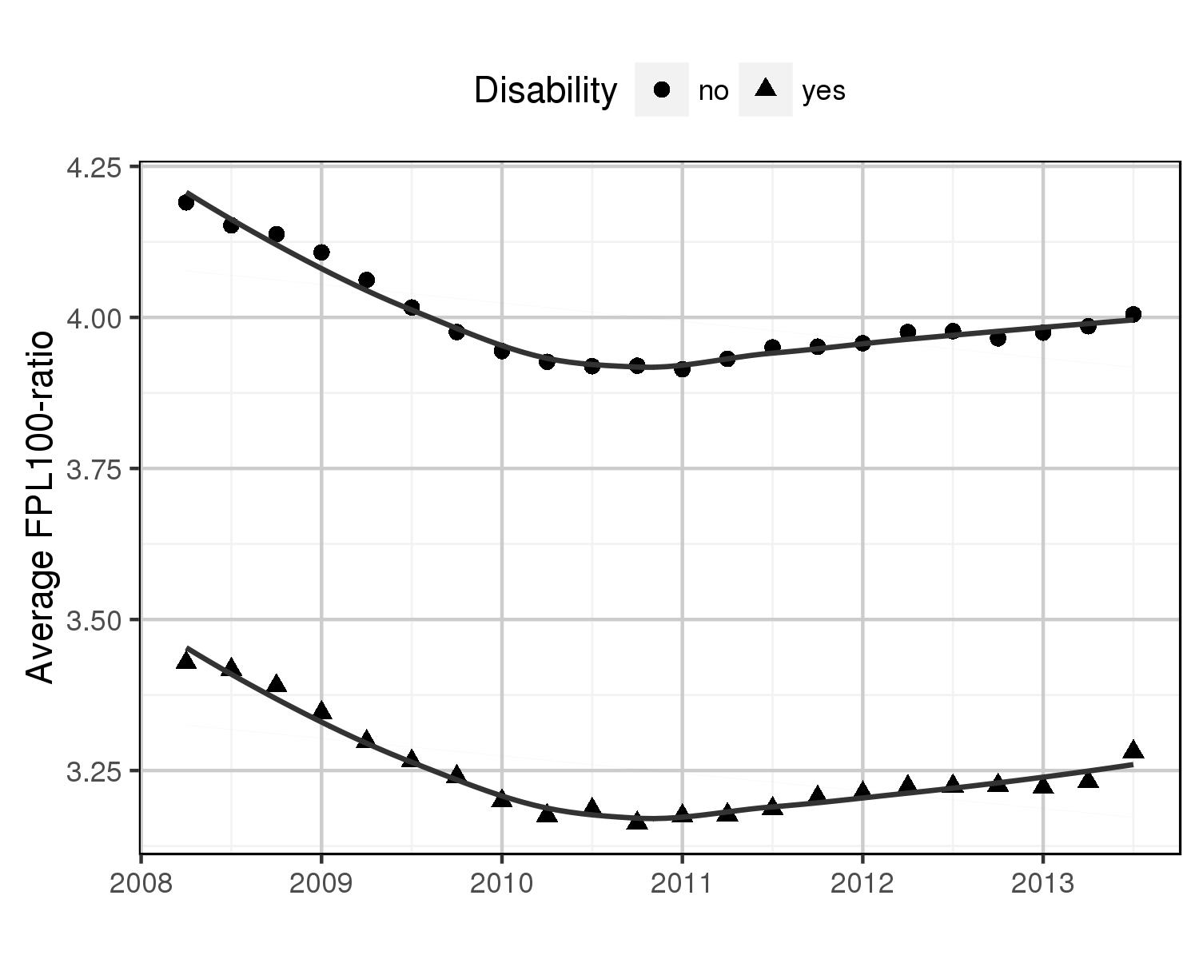



*Note*: Survey of Income and Program Participation (Wave 8

a FPL100-ratio: Calculated using quarterly averages of total monthly household incomes and monthly federal poverty levels averaged over three-months in each quarter

Lower FPL100 ratio implies higher poverty (federal poverty threshold > households income)

Figure 2: Income poverty ratio (FPL-100 ratio) profiles of two most contrasting household type

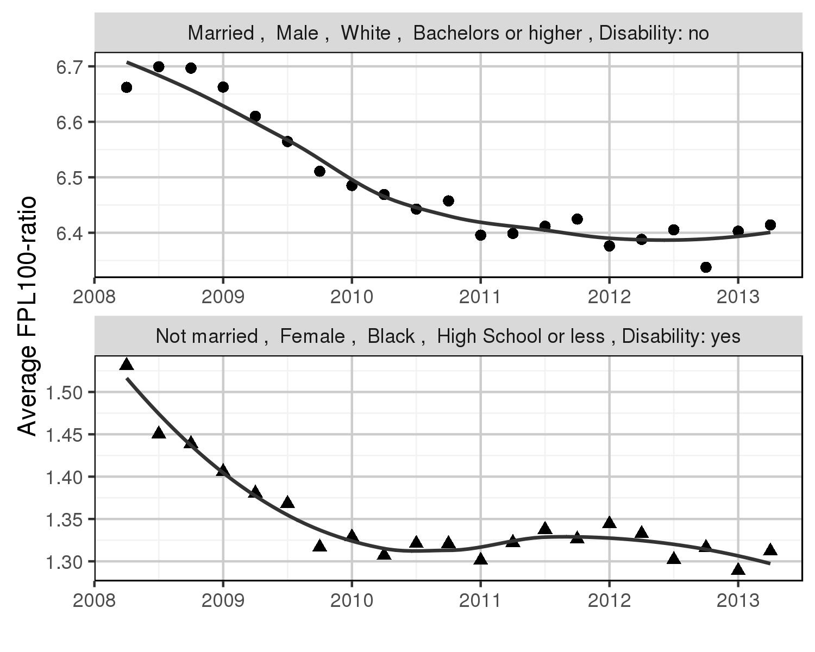

Figure 3: Income-poverty ratio (FPL-100 ratio) profiles for households with working-age adults with disability (a) by gender (b) by marital status (c) by race and ethnicity (d) by education, of reference person

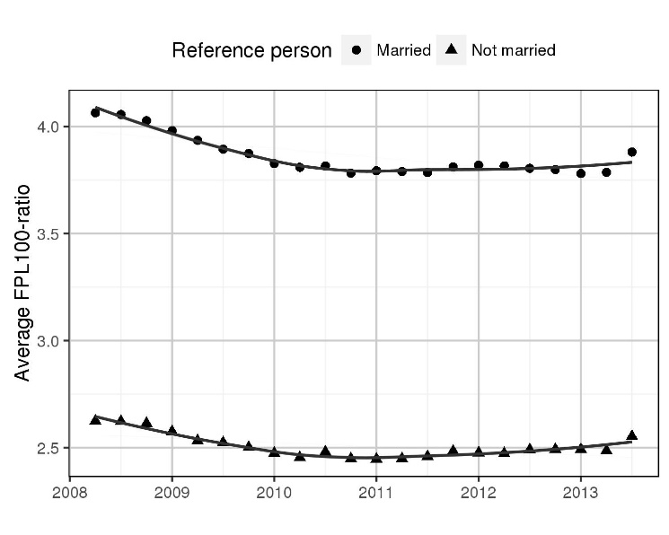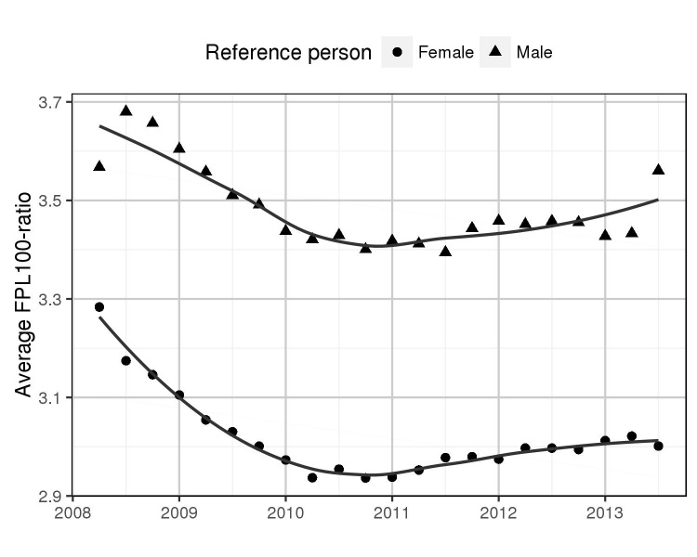 (a) (b)

(c) (d)

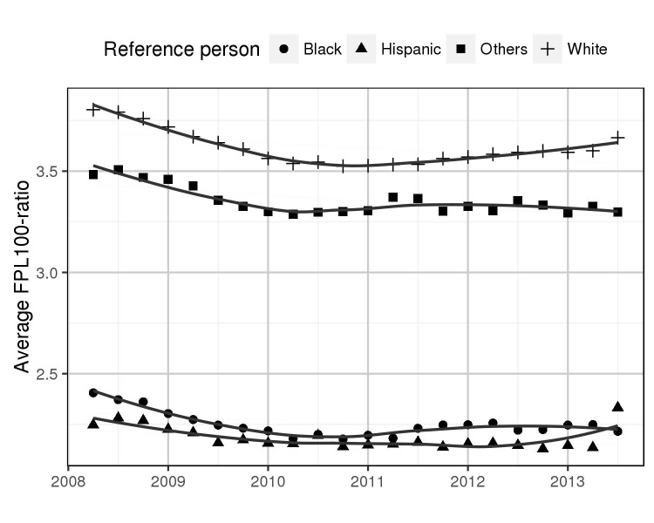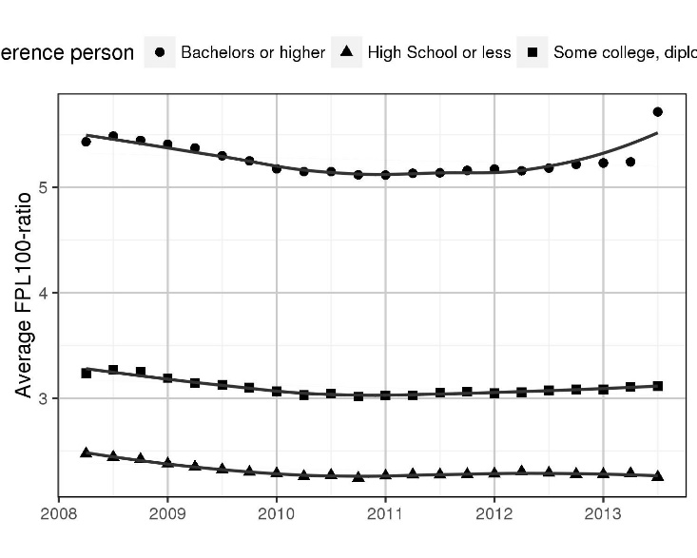

Figure 4: Patterns of safety-net program participation in households with working age adults with disabilities and those not. Analysis limited to households with income below 200% of the FPL

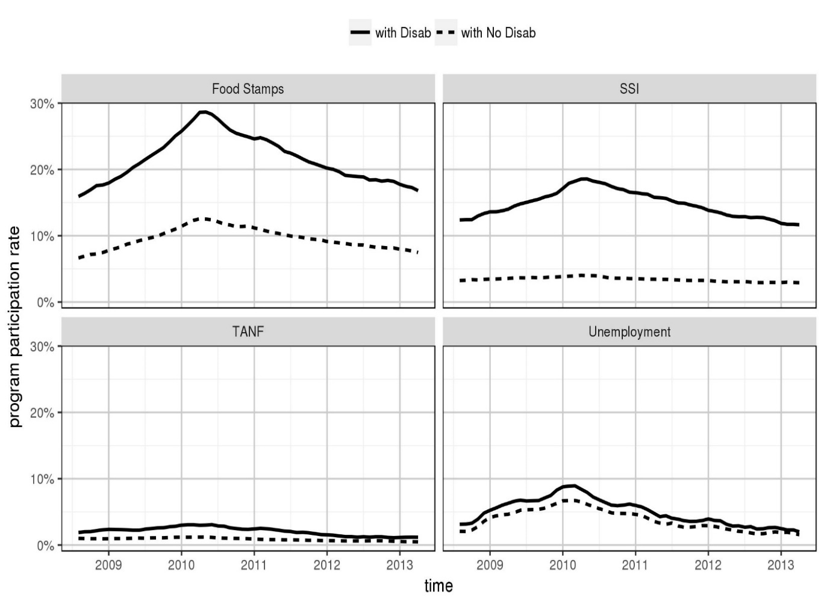

**Table 1.** Description of the study sample from wave 6 of the 2008 SIPP panel

|  |  |  |  |  |
| --- | --- | --- | --- | --- |
|  | **Households with no working-age adult with disability** | | **Households with working-age adult with** **Disability** | |
|  | **Number** | **%** | **Number** | **%** |
| Total number of households | 26,104 | 77.81 | 7,443 | 22.19 |
| Gender of the reference person |  |  |  |  |
| Male | 12,626 | 48.37 | 3,378 | 45.38 |
| Female | 13,478 | 51.63 | 4,065 | 54.62 |
| Marital status of the reference person |  |  |  |  |
| Married | 13,555 | 51.93 | 3,968 | 53.31 |
| Not Married | 12,549 | 48.07 | 3,474 | 46.67 |
| Race and ethnicity of the reference person | | | | |
| White | 18,765 | 71.89 | 4,965 | 66.71 |
| Hispanic | 2,996 | 11.48 | 908 | 12.20 |
| Black | 2,912 | 11.16 | 1,092 | 14.67 |
| Others | 1,431 | 5.48 | 479 | 6.44 |
| Education of the reference person | | | | |
| High school or less | 8,496 | 32.55 | 2,994 | 40.23 |
| Some college, diploma, associate’s  degree | 8,916 | 34.16 | 2,863 | 38.47 |
| Bachelors or higher | 8,692 | 33.30 | 1,586 | 21.31 |

Note: Weighted estimates are provided

**Table 2.** Mixed effects regression showing the difference in income poverty ratio between households with and without a working-age adult with disability

|  |  |  |  |
| --- | --- | --- | --- |
| **Predictor and Control variables** | *β* | **Std. Error** | **p-value** |
| Intercept | 5.896 | 0.037 | 0.0000 |
| Time (*t*) | -0.054 | 0.002 | 0.0000 |
| Time-squared (*t*2) | 0.007 | 0.001 | 0.0000 |
| Adult Disability a | -0.725 | 0.068 | 0*.*0000(f) |
| Adult Disability x Time | 0.015 | 0.004 | 0*.*9994(f) |
| Genderb: (Female) | -0.368 | 0.043 | 0.0000 |
| Marital status c: (Not married) | -0.611 | 0.034 | 0.0000 |
| Race2: (Black) d | -1.284 | 0.086 | 0.0000 |
| Race3: (Hispanic) d | -1.505 | 0.088 | 0.0000 |
| Race4: (Others) d | -0.355 | 0.087 | 0.0000 |
| Education2: (Some college, diploma, assoc) e | -1.516 | 0.045 | 0.0000 |
| Education3: (High School or less) e | -2.204 | 0.048 | 0.0000 |
| Adult Disability x Gender | 0.195 | 0.050 | 0.0001 |
| Adult Disability x Education: |  |  |  |
| Adult Disability x Education2 | 0.112 | 0.068 | 0.1002 |
| Adult Disability x Education3 | 0.219 | 0.072 | 0.0022 |
| Gender x Marital status | -0.523 | 0.032 | 0.0000 |
| *Gender* x *Education*: |  |  |  |
| Gender x Education2 | 0.102 | 0.051 | 0.0448 |
| Gender x Education3 | 0.255 | 0.052 | 0.0000 |
| *Marital status* x *Race*: |  |  |  |
| Marital status x Race2 | 0.209 | 0.051 | 0.0000 |
| Marital status x Race3 | 0.529 | 0.046 | 0.0000 |
| Marital status x Race4 | 0.182 | 0.069 | 0.0081 |
| *Marital status* x *Education*: |  |  |  |
| Marital status x Education2 | 0.125 | 0.037 | 0.0008 |
| Marital status x Education3 | 0.234 | 0.038 | 0.0000 |
| *Race* x *Education*: |  |  |  |
| Race2 x Education2 | 0.337 | 0.087 | 0.0001 |
| Race3 x Education2 | 0.401 | 0.092 | 0.0000 |
| Race4 x Education2 | -0.208 | 0.104 | 0.0460 |
| Race2 x Education3 | 0.371 | 0.093 | 0.0001 |
| Race3 x Education3 | 0.499 | 0.092 | 0.0000 |

Note: Only significant interactions (p-value < 0.05) have been reported.

a Base category ‘No disability’

b Base category of gender is ‘Male’

c Base category of marital status is ‘Married’

d Base category of race is ‘White’

e Base category of education is ‘Bachelors or higher’

f Note that these are p-values of one-sided tests based on hypotheses 1 and 2.

**Table 3.** Mixed effects regression testing the associations of demographic factors with income poverty ratio over time, for households with a working-age adult with disability

|  |  |  |  |
| --- | --- | --- | --- |
| **Predictor and Control variables** | *β* | **Std. Error** | **p-value** |
| Intercept | 5.361 | 0.076 | 0.0000 |
| Time (t) | -0.039 | 0.003 | 0.0000 |
| Time-squared (t2) | 0.006 | 0.002 | 0.0127 |
| Gender a: (Female) | -0.254 | 0.088 | 0.0039 |
| Marital status b: (Not married) | -1.119 | 0.070 | 0.0000 |
| Race2: (Black) c | -1.121 | 0.167 | 0.0000 |
| Race3: (Hispanic) c | -1.295 | 0.159 | 0.0000 |
| Race4: (Others) c | -0.325 | 0.162 | 0.0442 |
| Education2: (Some college, diploma, assoc) d | -1.668 | 0.088 | 0.0000 |
| Education3: (High School or less) d | -2.155 | 0.089 | 0.0000 |
| Gender x Marital status | -0.371 | 0.058 | 0.0000 |
| *Gender* x *Education:* |  |  |  |
| Gender x Education3 | 0.223 | 0.100 | 0.0263 |
| *Marital status* x *Race:* |  |  |  |
| Marital status x Race3 | 0.636 | 0.082 | 0.0000 |
| Marital status x Race4 | 0.288 | 0.115 | 0.0124 |
| *Marital status* x *Education:* |  |  |  |
| Marital status x Education2 | 0.641 | 0.074 | 0.0000 |
| Marital status x Education3 | 0.759 | 0.074 | 0.0000 |
| *Race* x *Education:* |  |  |  |
| Race2 x Education2 | 0.350 | 0.174 | 0.0438 |

Note: Only significant interactions (p-value *<* 0*.*05) have been reported.

Analysis limited to households with working-age adult with a disability

a Base category of gender is “Male”

b Base category of marital status is “Married”

c Base category of race is “White”

**Table 4.** Difference in rates of material hardship measures between and within households with a working-age adult with disability and those not, at two times points (wave 6 and wave 9)

|  |  |  |  |  |
| --- | --- | --- | --- | --- |
| Hardship measure | Households with working-age adult with disability  (N=4027) | | Households without working-age adult with disability  (N=10734) | |
|  | Wave 6a | Wave 9b | Wave 6a | Wave 9b |
| Did not pay full amount for gas or electricity c | 23.44% | 23.07% | 9.9% | 10.64% t |
| Did not pay full amount of rent/mortgage c | 14.53% | 14.65% | 7.37% | 7.88% |
| Did not meet all essential expenses c | 34.29% | 33.42% | 15.58% | 16.3% |
| Telephone company disconnect services because payments were not made c | 8.24% | 8.34% | 3.24% | 3.74%* |
| Needed to see a doctor, but did not go c | 21.16% | 19.87% | 6.57% | 7.59%** |
| Household did not have enough food to eat d | 8.15% | 8.47% | 2% | 2.56%** |
| Household could not afford balanced meal d | 28.93% | 29.13% | 11.66% | 12.96%** |
| Food bought but did not last and did not have enough to get more d | 30.2% | 30.37% | 13.12% | 13.84% |
| Households cut the size or skipped meals d | 14.95% | 16.17% | 4.24% | 5.4%*** |
| Households had less food to eat than they should because there wasn't enough money to buy food d | 15.5% | 16.89%t | 4.81% | 5.91%*** |
| Any hardships experienced | 48.89% | 48.42% | 23.01% | 24.75%** |
| Households experienced two or more hardships | 37.2% | 35.86% | 14.49% | 16.32%*** |
| Households experienced three or more hardships | 24.39% | 23.47% | 8.53% | 9.6%** |

Note: *** p<.001; ** p<.01; * p<.05; t p<.10

Results based on two proportion z test

Sample restricted to households with income below 200% of the FPL in either wave 6 or 9

a Wave 6: May 2010 to August 2010

b Wave 9: May 2011 to August 2011

c Reference period: Anytime in the last 12 months

d Reference period: Last 4 months

Difference between households with working-age adults with disabilities and those not, within each wave for every hardship measure is statistically significant

1. For more information on the SIPP 2008 panel schedule, please refer to this [US Census Bureau website](http://www.census.gov/programs-surveys/sipp/data/2008-panel.html)
2. NBER Recession cycles
3. These averages were weighted by monthly longitudinal survey weights
4. https://www.census.gov/programs-surveys/sipp/methodology/weighting.html
5. (bi  ̴ *N* (0, *σb2*), *εij*  ̴ *N* (0, *σ2*), *bi* ╨ *εij*, for all, i, j)
6. Business Cycle Dating Committee, National Bureau of Economic Research (NBER)